Module 5

- Power of Two - LeetCode

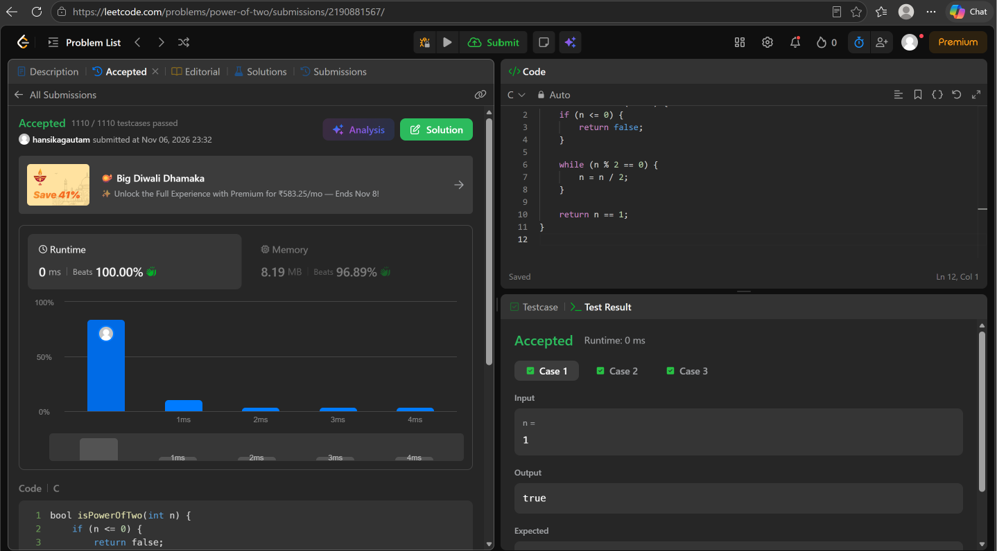

- Power of Three - LeetCode

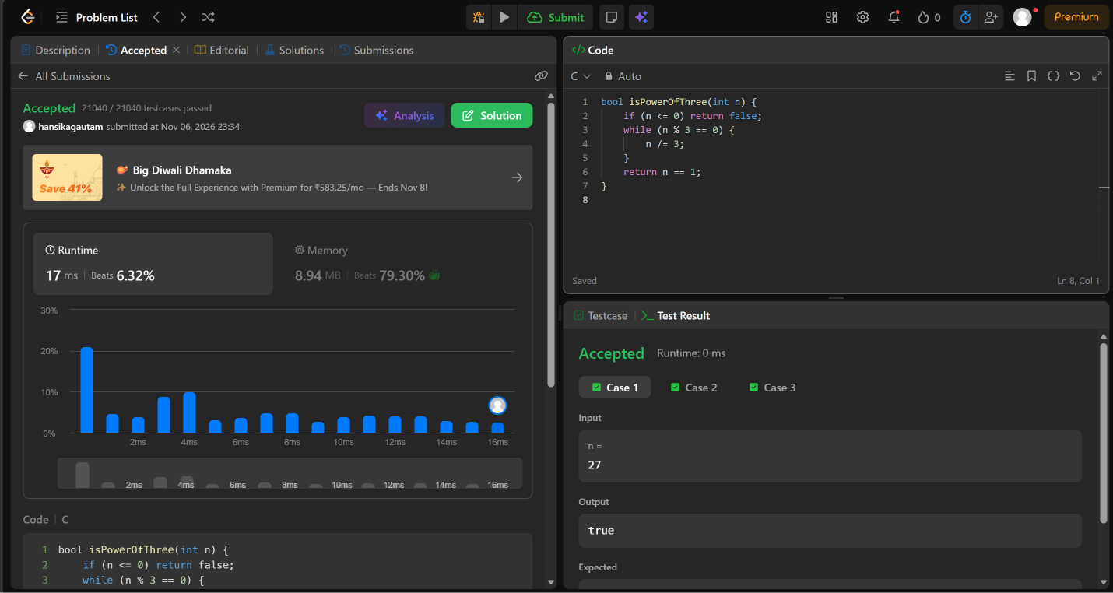

- Factorial! | Basics of Input/Output & Basic Programming Practice Problems
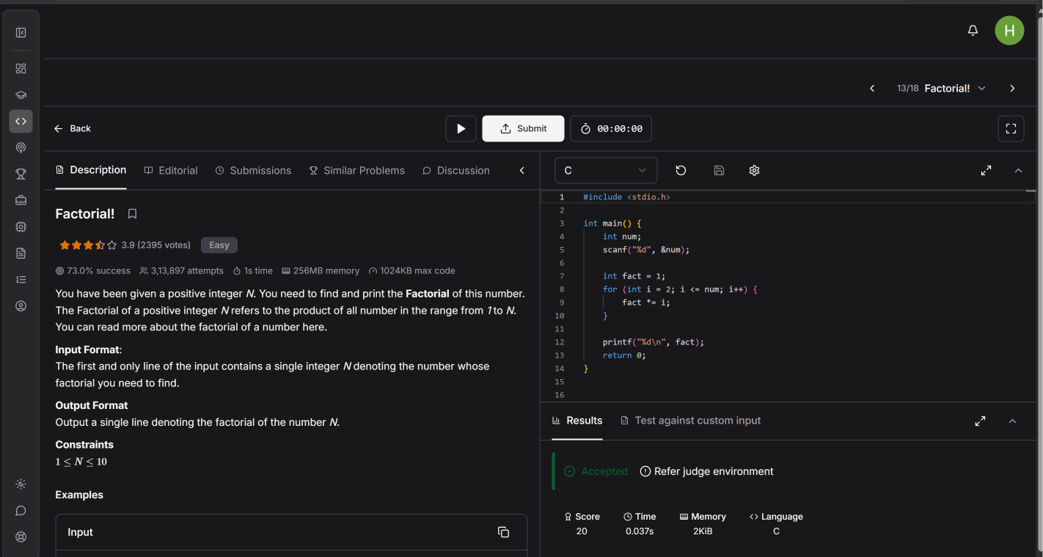

Count Divisors | Basics of Input/Output & Basic Programming Practice Problems
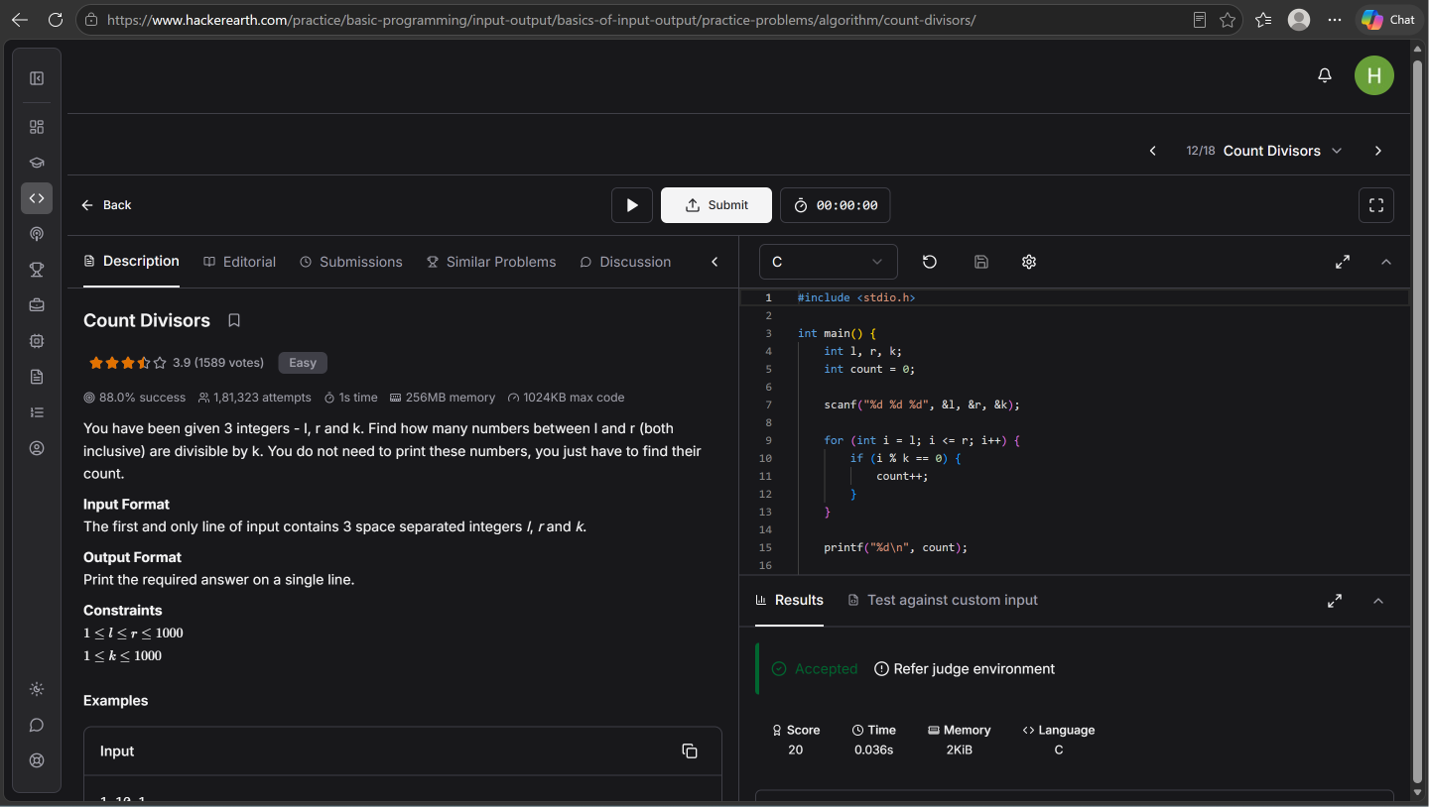

5 . Prime Numbers | Practice Problems

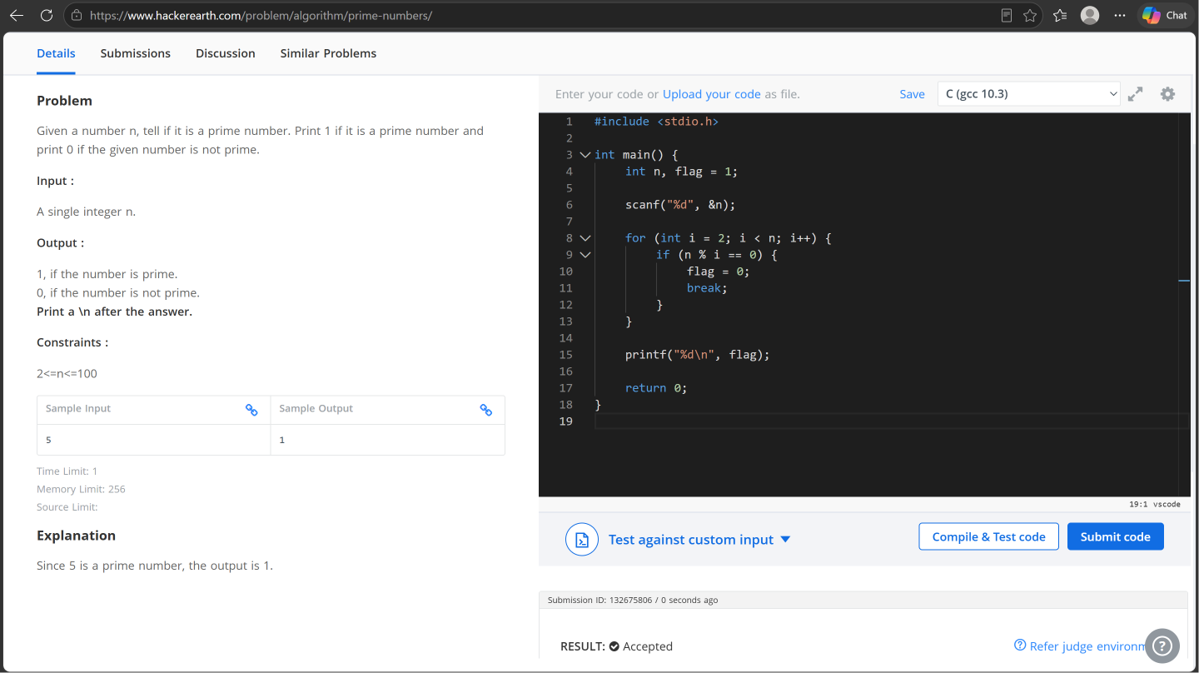

6 . Perfect Number - LeetCode


